For more information, contact: FOR IMMEDIATE RELEASE
Doug Roles March 16, 2020
Vice President of Member Services
droles@valleyrec.com

Valley Rural Electric leaders cancel 2020 Annual Meeting
as precaution against coronavirus spread

HUNTINGDON, Pa. – Leaders of Valley Rural Electric Cooperative announced today the cancellation of the April 3 annual meeting of co-op members due to the COVID-19 pandemic. The move is a precaution against possible spread of the coronavirus during what would have been a three-hour event that brings about 900 attendees into close proximity.
Co-op officials said the decision was made out of an abundance of caution and concern for the members and guests who attend. The meeting was to be held at Huntingdon Area High School.
“The health and safety of our members and employees is our top priority,” said James Stauffer, chairman of Valley REC’s board of directors. “Of particular concern is that a large percentage of those who attend our meeting are older members who are in an age group the Center for Disease Control and Prevention says is at increased risk from the coronavirus.”
The annual meeting is held for election of board directors and to provide members an update on their not-for-profit electric distribution business. Valley REC members will be informed of the cancellation through automated phone calls and through the co-op’s website and Facebook page.
“We’re disappointed that we won’t have a gathering of members this April, but we have to weigh our long history of annual meetings against the safety concerns this illness presents,” said Valley REC President & CEO Rich Bauer. “This year we had no contested races, so the three incumbent directors will continue to serve on the board.”
Valley’s service territory is comprised of nine director districts, with one member from each district serving on the co-op board. Each February, the co-op hosts three district meetings, at local fire halls or community centers, and members make nominations for board candidates. The nominees then stand for election to three-year terms at the annual meeting. Election is done by ballot by the members present.
The nominated incumbents are: Randall Huntsman of Martinsburg, Blair County, District 1; Kevin States of Hesston, Huntingdon County, District 3; and Robert Holmes of Huntingdon, Huntingdon County, District 5.
Valley Rural Electric is a member-owned cooperative providing electric service to more than 22,000 consumers in eight counties of south-central Pennsylvania, including Bedford, Blair, Centre, Franklin, Fulton, Huntingdon, Juniata and Mifflin. The co-op was incorporated Nov. 1, 1938 and energized its first lines a year later.

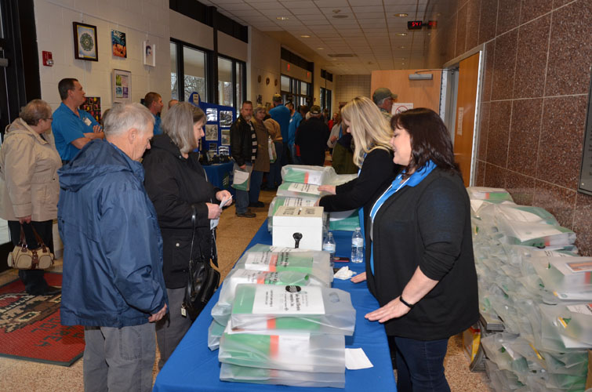
Valley Rural Electric Cooperative members arrive at Huntingdon Area High School April 5, 2019 to participate in the co-op’s annual meeting. Valley REC leaders have decided to cancel the 2020 event due to the coronavirus pandemic.

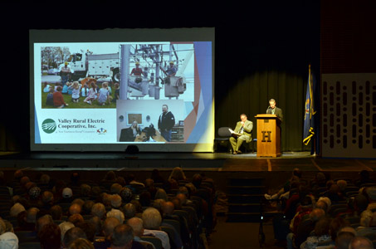

Valley Rural Electric Cooperative members gather in the Huntingdon Area High School auditorium for the co-op’s April 2019 annual meeting. The 2020 event, which was to be held Friday, April 3, has been canceled due to the COVID-19 pandemic.

###

